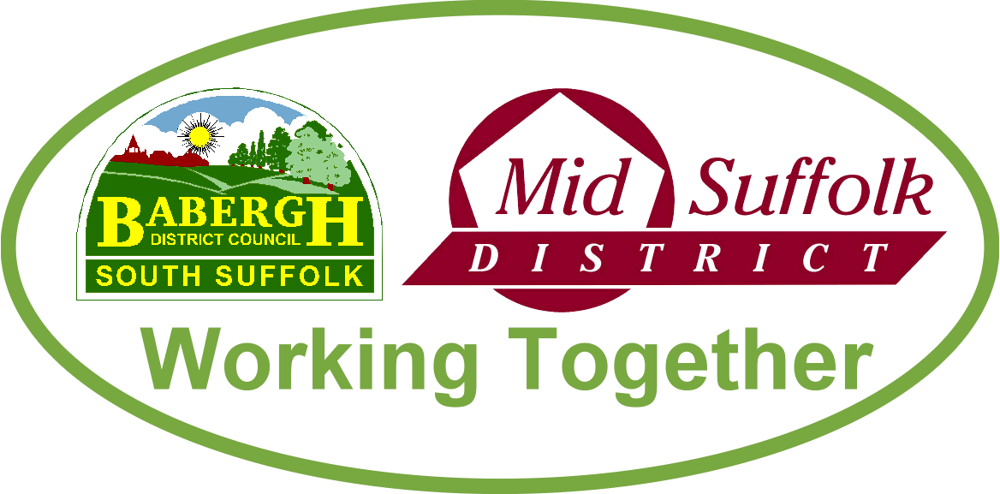

February 2023

Council tax freeze for Mid Suffolk?
Budget proposals for Mid Suffolk District Council published today include a council tax freeze for residents, despite rising costs and increased demands on services. More information

Babergh and Mid Suffolk District Councils take action over housing issues
Babergh and Mid Suffolk District Councils are taking action to improve their Building Services - which maintain their council housing - and urgently resolve a number of issues. More information

Groundbreaking at Gateway 14, Stowmarket, for The Range
Construction of a state-of-the-art distribution unit for garden and leisure products retailer The Range is officially underway at Gateway 14. More information

Freeport East Receives Final Government Approval
Freeport East has received final Government approvals today allowing it to move forward into the delivery phase. More information

‘Magic tables’ bringing joy to Mid Suffolk’s care homes
Interactive tables with therapeutic effects for people living with dementia are being trialled in Mid Suffolk’s care homes. More information

Full business case to be developed for Stowmarket wellbeing and leisure hub
Progress of the Stowmarket health, wellbeing, sports, education, and leisure facilities will be presented to Mid Suffolk District Council cabinet in February, with approval being sort for the next phase of the business case. More information
Supporting the elections this May
As you will know, the local and parish elections are due to be held on Thursday 4 May. There are still positions that need to be filled to ensure the elections are run smoothly across the districts. If you want to get involved, or know someone else who is interested, email the Babergh and Mid Suffolk elections team to find out more.

Voter ID
The UK Government has introduced a requirement for voters to show photo ID when voting at a polling station, which will be implemented in the upcoming local and Parish elections in May. More information

